Nama : Anggita Puspaningrum  
NIM : L200160096

MODUL 10

PERCOBAAN 1

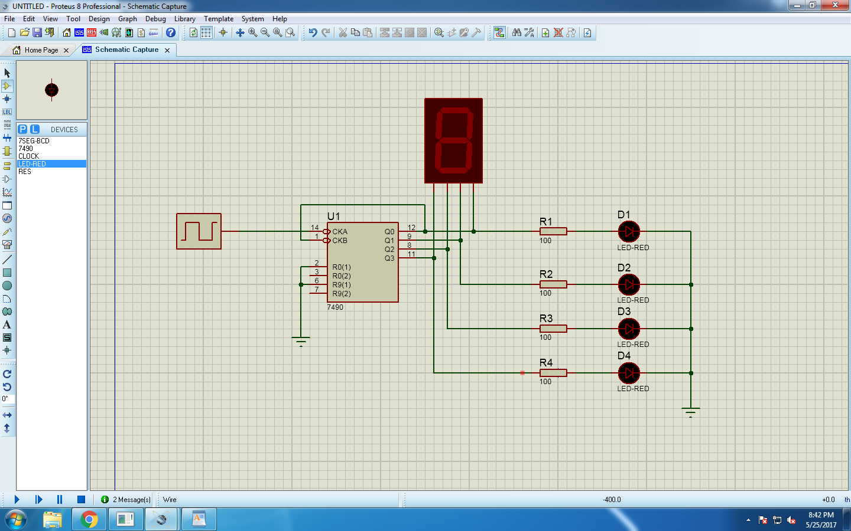

Tabel Kebenaran

|  |  |  |  |  |  |
| --- | --- | --- | --- | --- | --- |
| Input Clock | Output LED | | | | Output Seven Segment |
| D1 | D2 | D3 | D4 |
| 1 | L | L | L | L | 0 |
| 2 | H | L | L | L | 1 |
| 3 | L | H | L | L | 2 |
| 4 | H | H | L | L | 3 |
| 5 | L | L | H | L | 4 |
| 6 | H | L | H | L | 5 |
| 7 | L | H | H | L | 6 |
| 8 | H | H | H | L | 7 |
| 9 | L | L | L | H | 8 |
| 10 | H | L | L | H | 9 |
| 11 | L | L | L | L | 0 |
| 12 | H | L | L | L | 1 |
| 13 | L | H | L | L | 2 |

PERCOBAAN 2

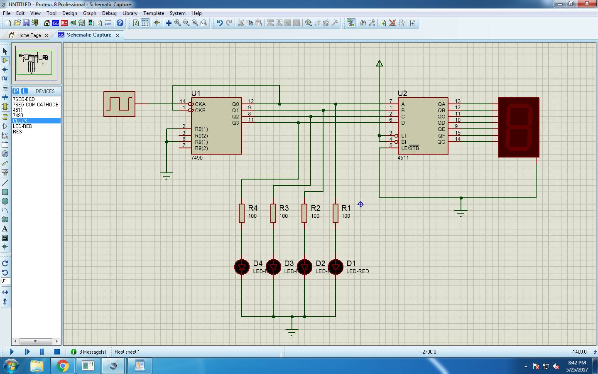

Tabel Kebenaran

|  |  |  |  |  |  |
| --- | --- | --- | --- | --- | --- |
| Input Clock | Output LED | | | | Output Seven Segment |
| D1 | D2 | D3 | D4 |
| 1 | L | L | L | L | 0 |
| 2 | H | L | L | L | 1 |
| 3 | L | H | L | L | 2 |
| 4 | H | H | L | L | 3 |
| 5 | L | L | H | L | 4 |
| 6 | H | L | H | L | 5 |
| 7 | L | H | H | L | 6 |
| 8 | H | H | H | L | 7 |
| 9 | L | L | L | H | 8 |
| 10 | H | L | L | H | 9 |
| 11 | L | L | L | L | 0 |

Pada percobaan 1 dan percobaan 2 menghasilkan nilai sama pada output LED maupun output seven segment.

Ya, benar bahwa 7seg-BCD sama dengan BCD-to-7segment

PERCOBAAN 3

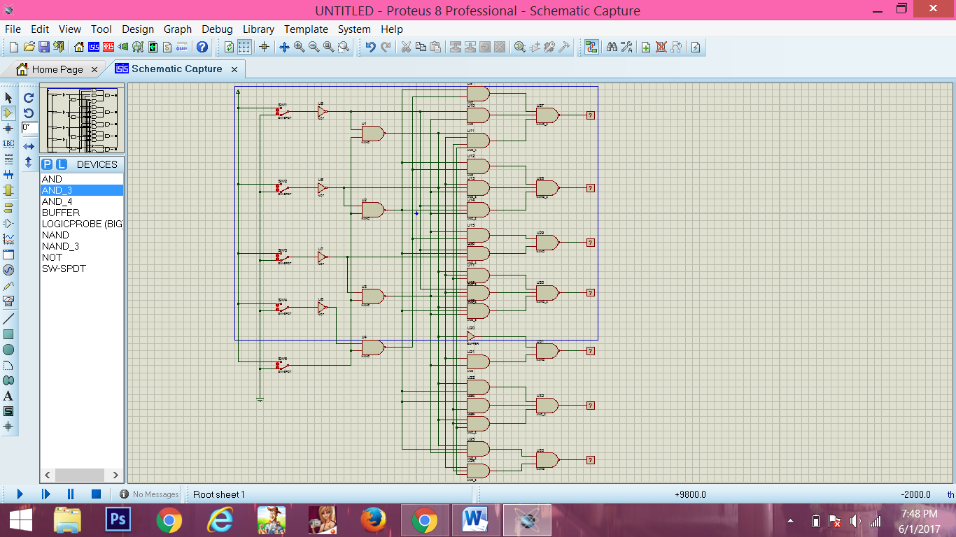

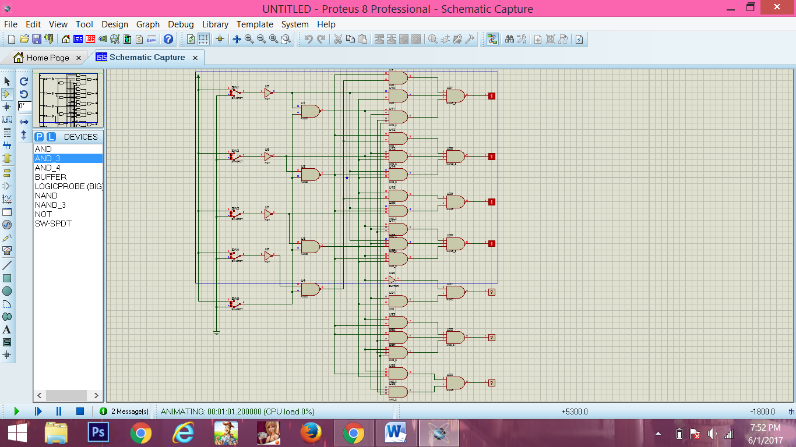

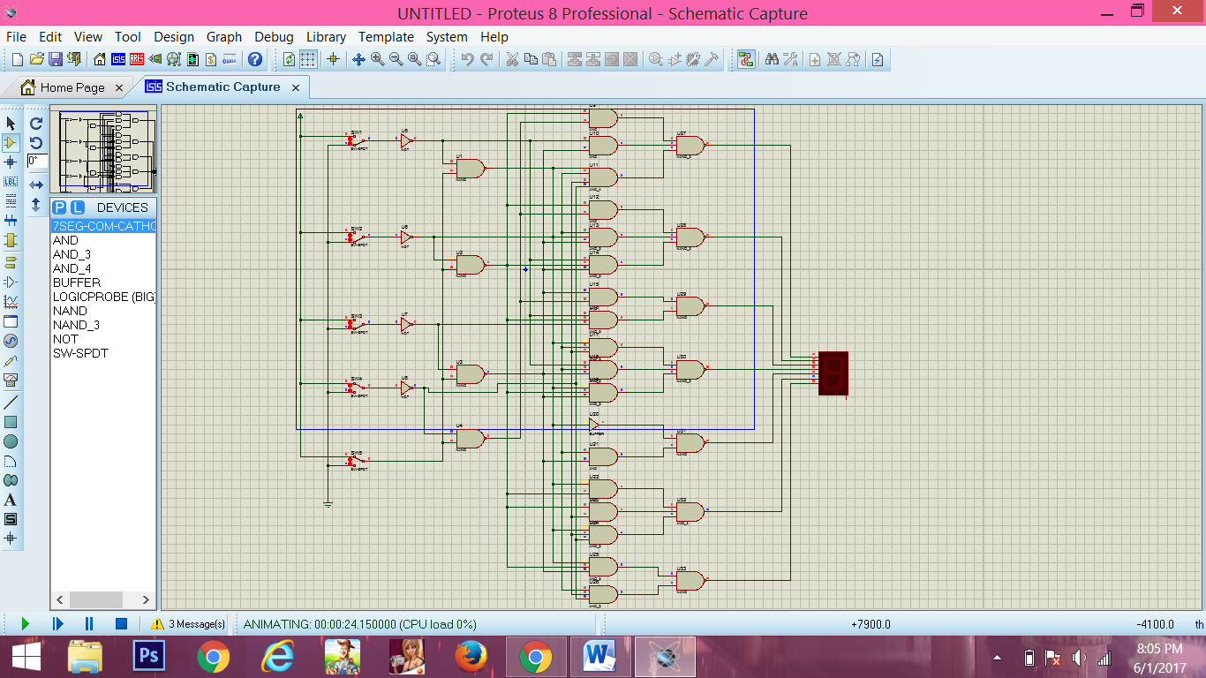

Tabel Kebenaran

|  |  |  |  |  |  |  |  |  |  |  |  |  |  |  |
| --- | --- | --- | --- | --- | --- | --- | --- | --- | --- | --- | --- | --- | --- | --- |
| Decimal Digit | Input | | | | | | Output | | | | | | | Display Output |
| LT | D | C | B | A | a | | b | c | d | e | f | g |
| 0 | H | L | L | L | L | H | | H | H | H | H | H | L | 0 |
| 1 | H | L | L | L | H | L | | H | H | L | L | L | L | 1 |
| 2 | H | L | L | H | L | H | | H | L | H | H | L | H | 2 |
| 3 | H | L | L | H | H | H | | H | H | H | L | L | H | 3 |
| 4 | H | L | H | L | L | L | | H | H | L | L | H | H | 4 |
| 5 | H | L | H | L | H | H | | L | H | H | L | H | H | 5 |
| 6 | H | L | H | L | H | H | | L | H | H | L | H | H | 6 |
| 7 | H | L | H | H | H | H | | H | H | L | L | L | L | 7 |
| 8 | H | H | L | L | L | H | | H | H | H | H | H | H | 8 |
| 9 | H | H | L | L | H | H | | H | H | L | L | H | H | 9 |
| LT | L | X | X | X | X | H | | H | H | H | H | H | H | 8 |